

**5**

**Pitfalls to Avoid when applying to extend your UK Working Visa or Right to remain.**

***Abiodun K. Adesanya Business Owner/ CEO***

Introduction

The top 5 pitfalls or problems an applicant can do away with when making an application for their visa or for an extension is as follows:

**PITFALL No.1**

Not getting the right advice or information as to what should go into your application



This is a problem because there is certain information and formats and if you do not get it right your application will likely get rejected.

For example, an extension or conversion application for workers, you will need to apply within their previous valid visa time, renewed Certificate of Sponsorship, Health surcharge, visa fee etc. If any of this information is missing for an extension visa, then your application will most likely get rejected. For international student Certificate of Acceptance of offer (CAS), School fees etc.

On application if you are supposed to provide three of the above documents and you misinterpret this and provide just only two and leave the remaining ones then your application may be automatically rejected.

Impact: Rejection of application is really important because it cannot be currently applied for another 3months or you may have to make another payment of £300 appeal fee for a new application. The solution is to get the right advice from an immigration lawyer so that you get the right information on your form at the first time around.https://lh4.googleusercontent.com/smJFsvFahmepBSWrYwiGYbJSxn64_kjDbRRyT8X8xCG61xoBazsxCZ2iWUvdcRE7vjaKRwhCVT6pcuEorioZ6zDlYxr4hc9_ZThbSwnLxiWPkR8uaXnQ1hKQZ3C9X5Goy_iKqLY

The case study: Imagine Jade might need to apply to extend her right to remain in UK along with the rest of her family who already have a longer right to remain, if she does not get the right information for the first time then she leaves the application till the last minute. She could become an over stayer and subject to deportation and be taken away from her family.

The above is just an example of an impact of getting wrong information for your application. There are other pitfalls people might fall into by doing it by themselves which are covered below.

**PITFALL No.2**

Not providing the right documentation to support your application

This important because there are certain documents required to be submitted with your application in certain format and if you do not get it right or submit the necessary documents your application may get rejected.

 For example, an extension or conversion application for workers, you will need to apply within their previous valid visa time, renewed Certificate of Sponsorship, Health surcharge, visa fee etc. If any of this is missing during application for extension such an application may be rejected. For international student Certificate of Acceptance of offer (CAS), School fees etc. On application if you do not provide adequate number of documents required for your application then your application may be automatically rejected. If you will need to apply for student visa extension, current passport or valid travel documentation, confirmation of acceptance of studies from your course will be needed. The solution to this is to provide the right documents on your first application

**PITFALL No.3**

Not following the legal requirements for your application

This is important because putting forward required documents and proper information for example for student visa extension your course name , your name, course duration and your travel documents should be properly match up with CAS. Also, the travel document must have six month of validity.  For student visa: proof of legal guardian consent, proof of your relationship to your parent or guardian if you are under 18, tuberculosis test result and evidence of financial support is very important and the effect is that your application may be refused. To avoid this, the legal requirements for your application needed to be strictly adhering to for your visa application to be granted.

**PITFALL No.4**

Lack of adequate information may lead to application being rejected

For example, Jade came into this country as a UK non-national  after 3years of working in the UK she needed an extension of two more years making 5years before she can be granted right to remain but unfortunately she did not apply for an extension on time within the time frame  and her application was rejected. She became an Over stayer not knowing that she can still make the application within 14days of her expired 3 years working visa later she was eventually deported to her home country. The impact is that she became an over stayer in UK and the solution is that she may need to contact an immigration Lawyer for adequate information that could help her in visa application for extension.

 This is a problem because if rejected for the first time there is likelihood for another rejection   next even after providing the proper document so as a result there may be need to apply with the right information or documentation at the first time.

The impact is that this may be rejected and it will have a continuous impact on future applications. For example if rejected in UK there is every possibility of other countries to rely on the number of rejection the applicant has already have in the past which actually form part their decision on the visa application.

 The result of making the application yourself is faced with many elongated uncertainties attached to emotional issues of stress to mention a few. The solution is to get it right at the first time by getting a professional help as our Law firm.

**PITFALL No.5**

Becoming a victim of Fraud

One of the Immigration skills Charge £364 for first year and £182 for the each additional year and the Visa fees up to 3 years is £610, any contrary may not be inappropriate.

To avoid risk of falling into a wrong hand and becoming a fraud victim, approach an immigration Lawyer for specialist advice and standard fee for your visa application or extension to avoid unnecessary spending.

The solution is to get it right at the first time by getting a professional help as our Law firm. The outcome of applying themselves eventually resulted in waste of resources, time, effort and also exposes you to the fraudulent and criminality. You may also develop an emotional stress and a risk of overstaying which may leads to deportation, leaving the country separating from their friends and family.

**SESSION OFFER**

NEXT STEP INVITATION 2 Session or Right to Remain Review Session If you would like to learn more about how to avoid the common pitfalls that could cause your visa application extension or right to remain application to be refused, then you can apply for a no-cost ‘Extension or the Right to remain Review session’ Strategy Session with me which is 30 minute free session, by phone or Skype video call. In this session, I will:

• Review your situation to see the challenges you might face with your application.

• Identify the specific pitfalls that could cause your application to be refused

• Plan out your next steps to maximise the likelihood of a successful application first time.

**To book your session please email abbeydlaw@gmail.com or info@abbeydelawfirm.com or call +44 7828842376/07309593771 to discuss how our services can benefit you further.**

**ABOUT THE AUTHOR**



A

biodun K Adesanya is the Business Owner and the Director of Abbey De Law Firm, a professional and vibrant legal practice which specialises in immigration services helping UK non-nationals who needs visa application or an extension and the Right to remain in UK. After 20 years’ experience as a specialist Immigration Solicitors, helping hundreds of clients, she understands the many problems or pitfalls faced by the UK non-nationals who needs visa applications or an extension

Abi’s approach is all about helping you maximise the chance of getting successful application by identifying the pitfalls you might have on your own, having you avoid those challenges and help you take my expertise and make sure that it is used to give you the most successful outcome on your application or extension.

Abi, has exhibited professionalism with years of experience and multiple academic qualifications including a Bachelor of Laws, Masters in Local Development & Innovation and a Bachelor in Applied Social Studies in Social Care. She bottled an Advocate for International Development certification while studying LPCLLM at the University of Law 2017-2019. She had several Leadership Trainings; Leadership, Supervisory & Management Skills (Sanctuary-Appraisals), Level 8 Strategic Direction and Leadership.

She has been certified for British Mental Health Certification, 2019 and an Accredited Trainer certification in 2021 and registered data controller for the company and also had training in Immigration courses OISC Level 1, 2 and 3.

She has demonstrated outstanding in Diversity and Equal opportunity at workplace as an employer during her engagement with the public, private and corporate organisations. Introducing Employment law as a tool to work with the participants of the Kick-Start scheme from the DWP and recruiting participants from different backgrounds to promote diversity as a reflection of all backgrounds. She will offer dispute resolutions at every stage of our dealings; help clients resolve disputes in all matters compared to her other colleagues.

**Testimonial**

*Women’s Business Leaders recently nominated Abiodun K Adesanya for “Women in Law” Awards after recognizing the value of her work which involves anti-discriminatory practices without any form of discrimination with a diverse mind. Wishing to contact Abi using the above contact details*

**TESTIMONIALS for non-discriminatory Practises with a few point of diversity – LINKEDIN**

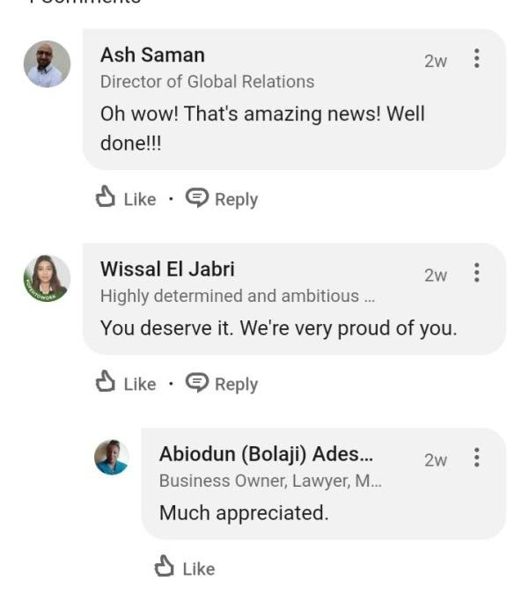



***For further information please contact***

***Email: abbeydlaw@gmail.com or info@abbeydelawfirm.com***

***Tel: +44 7828842376/07309593771***